**Project 4 Part 1 (k-means for 100 2d points)**

Name: _____________Michael Fatemi_______________ Period: ______7______

Date: _____________1/6/2021___________

Is your lab name l041?(lowercase L followed by digits 041) _____Yes______

Did you created a class to store a point? _____Yes______

Does your main contain only a call of method part1()? ______Yes_____

Paste here 2 clear pictures of the clusters.ppm you created in 2 different runs:

First clusters.ppm:

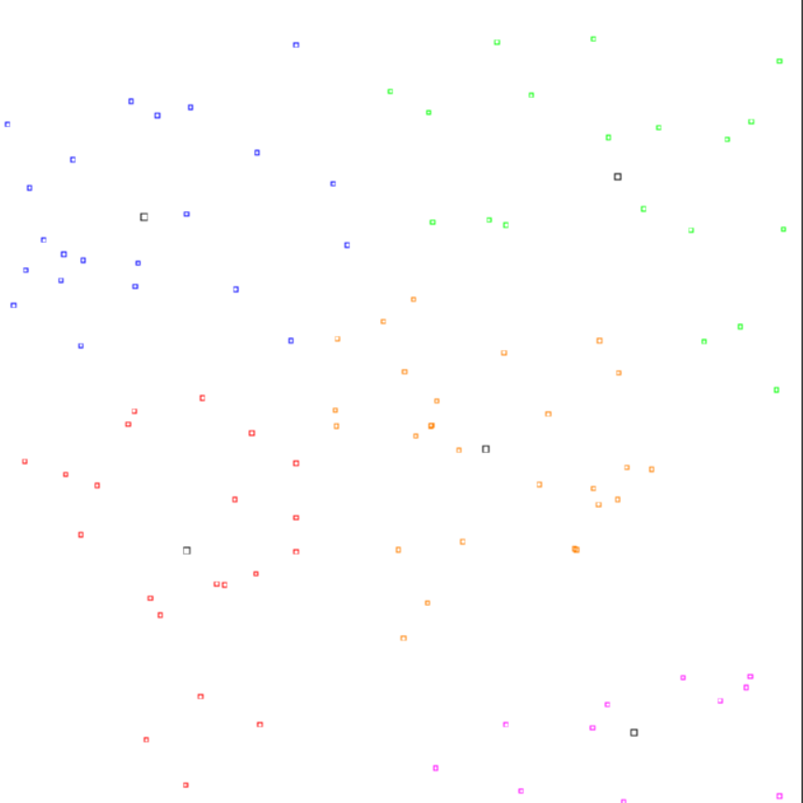

Second clusters.ppm:

